**PROGRAM:**

#include<iostream>

using namespace std;

int main(){

int i,j,n=5;

for(i=0;i<=n;i++)

{

for(j=0;j<=i;j++)

{

cout<<"*";

}

cout <<"\n";

}

}

**OUTPUT:**

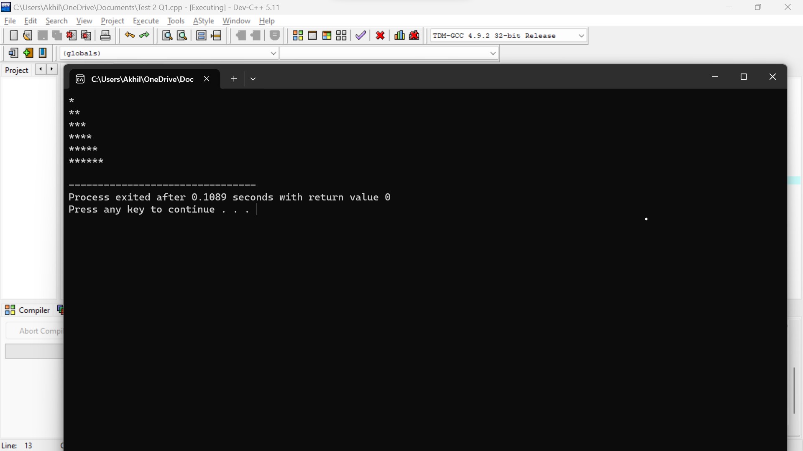

**PROGRAM:**

#include<iostream>

using namespace std;

int main(){

int arr[]={1,2,3,4,5};

int n=sizeof(arr)/sizeof arr[0];

int sum=0,i,avg;

for(i=0;i<n;i++)

{

sum=sum+arr[i];

avg=sum/n;

}

cout<<avg;

}

**OUTPUT:**

